**Module (Bootstrap Basic & Advanced) – 6**

**Que 1. What are the advantages of Bootstrap?**

ANS - Easy initiation. Coding is a hurricane task for a person who is unbeknownst to web development. ...

Responsiveness.

Highly customizable.

Extremely user-centric.

Top-notch support.

Cross-browser compatibility.

JavaScript plugins to your rescue.

Far-reaching popularity.

**Que 2. What is a Bootstrap Container, and how does it work?**

Ans -A **Bootstrap Container** is a fundamental layout element in the Bootstrap framework, used to contain and center the content of a webpage. It provides structure, padding, and responsive behavior, ensuring that your content looks good across different screen sizes and devices.

**Types of Bootstrap Containers:**

There are two main types of containers in Bootstrap:

1. **.container (Fixed-width Container):**
   * This type of container has a responsive, fixed width. It adapts to the screen size, but the width is restricted to predefined breakpoints. The container will adjust at these breakpoints:
     + Extra small (xs): 100% width (up to 576px)
     + Small (sm): 540px width (≥576px)
     + Medium (md): 720px width (≥768px)
     + Large (lg): 960px width (≥992px)
     + Extra large (xl): 1140px width (≥1200px)
     + XXL (xxl): 1320px width (≥1400px)
2. **.container-fluid (Fluid-width Container):**
   * This container is 100% wide at all viewport sizes. It spans the entire width of the viewport and does not follow the fixed breakpoint widths like the .container. It is typically used when you want your content to stretch and fill the entire screen width, regardless of the device size.

**How it Works:**

* A Bootstrap container wraps your content and applies margins and paddings to align it properly within the viewport.
* The container works alongside Bootstrap's grid system, ensuring that your content is aligned according to rows and columns, making it responsive.

**Que 3.What are the default Bootstrap textsettings?**

**ANS -** Summary of Key Bootstrap Text Settings:

* Font family: Sans-serif stack
* Font size: 1rem (16px)
* Font weight: 400 (normal)
* Line height: 1.5
* Text color: #212529
* Text alignment: Left (by default), customizable with utility classes
* Responsive text utilities for font size and alignment

These default text settings provide a good balance of readability and accessibility, while still being customizable with Bootstrap's utility classes.

**Que.4 What do you know about the Bootstrap Grid System?**

**ANS -** The Bootstrap grid system is a responsive layout system for web pages that uses rows, columns, and containers to arrange content. It's built with flexbox and scales up to 12 columns as the size of the device or viewport increases. The grid system automatically rearranges the columns based on the screen size.

Here are some features of the Bootstrap grid system:

* Responsive: The grid system is responsive and scales to fit the size of the device or viewport.
* Predefined classes: The grid system includes predefined classes for easy layout options.
* Mixins: The grid system includes mixins for generating more semantic layouts.
* Column classes: The grid system has four classes for different screen sizes: xs for phones, sm for tablets, md for small laptops, and lg for laptops and desktops.
* Layout: The grid system uses a 12-column layout that can be combined or subdivided to fit your design needs.

**Que.5 What is the difference between Bootstrap 4 and Bootstrap5**

**ANS -**

| **Feature** | **Bootstrap 4** | **Bootstrap 5** |
| --- | --- | --- |
| jQuery | Required for JavaScript plugins | Removed, now vanilla JS |
| IE Support | Supports IE10 & IE11 | Dropped IE support |
| Grid System | 5 Breakpoints (xs to xl) | 6 Breakpoints (xxl added) |
| Form Controls | Basic controls | Redesigned, with floating labels |
| Utility API | Basic utility classes | Advanced utility API |
| Icons | No native icon set | Bootstrap Icons (SVG-based) |
| CSS Variables | Limited | Extensive use of CSS variables |
| Offcanvas | No | New Offcanvas component |
| Responsive Font Sizes | No | Yes |
| RTL Support | Limited | Improved RTL support |
| JavaScript | jQuery-based plugins | Vanilla JavaScript (ES6+) |

**Que 6.** **What is a Button Group, and what is the class for a basic Button Group?**

**ANS -** A Button Group in Bootstrap is a UI component that allows you to group a series of buttons together on a single line. This is useful when you want buttons to be treated as a group of actions, and it ensures consistent alignment and spacing between the buttons.

Basic Structure of a Button Group:

To create a basic button group, you use the .btn-group class, and then include individual buttons with the .btn class inside it.

**Que.7 How can you use Bootstrap to make thumbnails?**

In Bootstrap, **thumbnails** are a way to display images or other content in a grid-like layout with a frame around them. You can create thumbnails by using the .img-thumbnail class, which adds a border, padding, and a background to an image, making it stand out.

**Basic Thumbnail Example:**

Here’s a simple way to create a thumbnail for an image:



**Thumbnails in a Grid Layout:**

If you want to display multiple thumbnails in a grid, you can use the Bootstrap grid system. Here's an example:

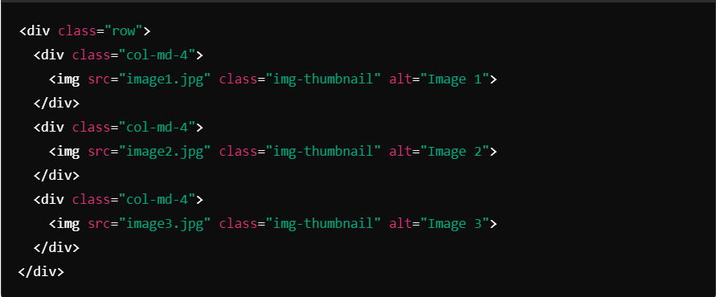

**Additional Features:**

* The .img-thumbnail class makes the image responsive (it scales according to the size of the parent container).
* You can wrap thumbnails in links or use them inside cards or other Bootstrap components for more advanced layouts.

**Que.8 In Bootstrap 4, what is flexbox?**

**ANS -**

* Creating responsive navigation bars.
* Building flexible grids with equal-width columns.
* Centering content vertically and horizontally with minimal CSS.
* Implementing reordering of items for different screen sizes.
* Flexbox in Bootstrap 4 offers powerful and simple utilities to create modern, responsive, and adaptive layouts, making it a crucial part of the framework.

**Que.9 How can one create an alert in Bootstrap?**

**ANS -**

* Use the .alert class for the basic alert structure.
* Use contextual classes like .alert-success, .alert-danger, .alert-warning, etc., to define the alert type.
* Add .alert-dismissible and a close button to create dismissible alerts.
* You can include headings, links, and other elements inside alerts to further customize them.

**Que.10 What is a bootstrap card and how would you create one?**

**ANS-** Key Components of a Bootstrap Card:

1. .card: This is the main class for creating the card container.
2. .card-img-top: Used for adding an image at the top of the card.
3. .card-body: The body of the card, where most of the content (text, buttons, etc.) goes.
4. .card-title: A class for the card's title (usually a heading).
5. .card-text: For adding descriptive or main content inside the card.
6. .btn: You can add buttons within the card, like a call-to-action button.
7. 